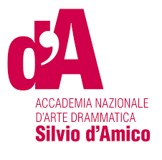
CONTAMINAZIONI 2018
E:UTSA Members
XII Edition
Teatro India
Lungotevere Vittorio Gassman 1, Rome

APPLICATION FORM
Title holder of the project:
School: | Phone number: | Indirizzo e-mail: |  | Residence address:
Project’s title:

Name of the author specify whether the text is unpublished):
Translation used:
Length of the project (miutes):
Synopsis (for the brochure – max 500 characters):

Project description (max 2000 characters):

Participants’ details:
Name | School | Phone number | E-mail address |  | Residence address

